Ho to access azure key vault value through azure app service application setting value in C# code

1. Create Keyvault and create secret in key vault.

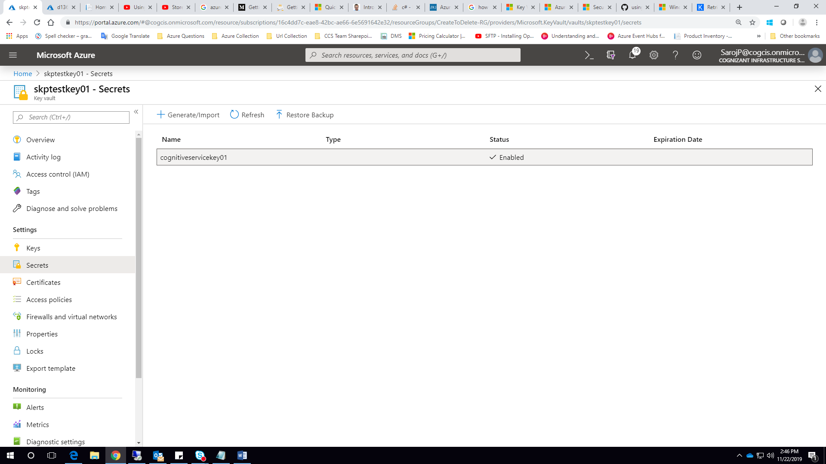

Create a App service :

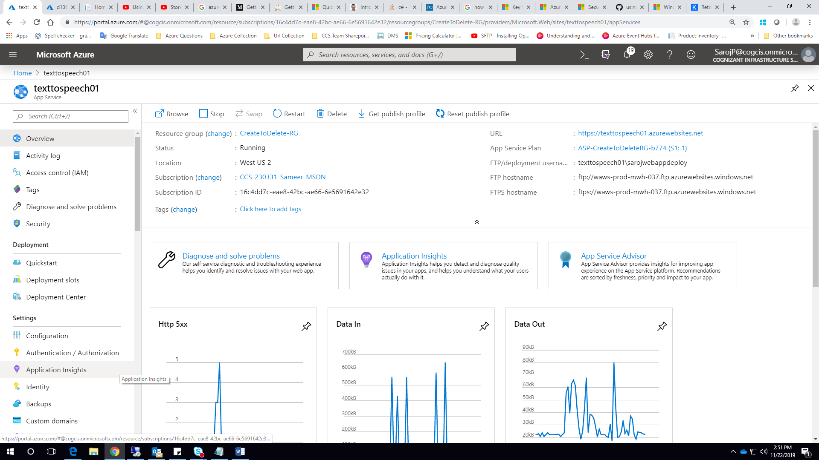

Go to Identity option and do Sysytem assigned if not

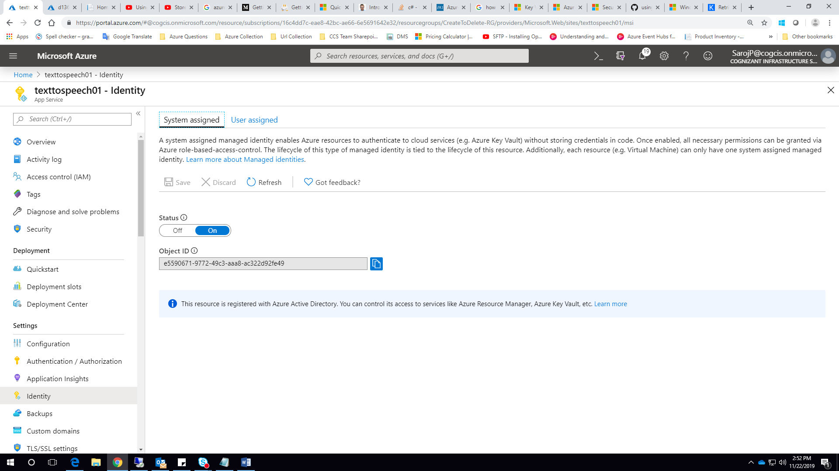

1. Add policy to add your application (app service where deployed ur app)

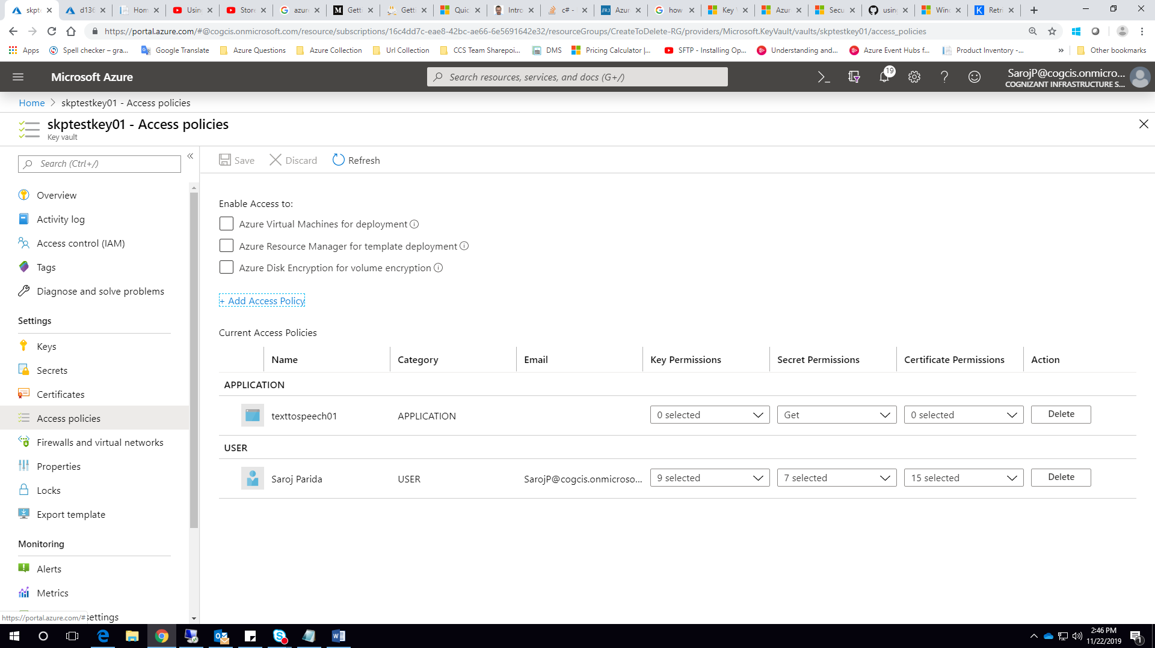

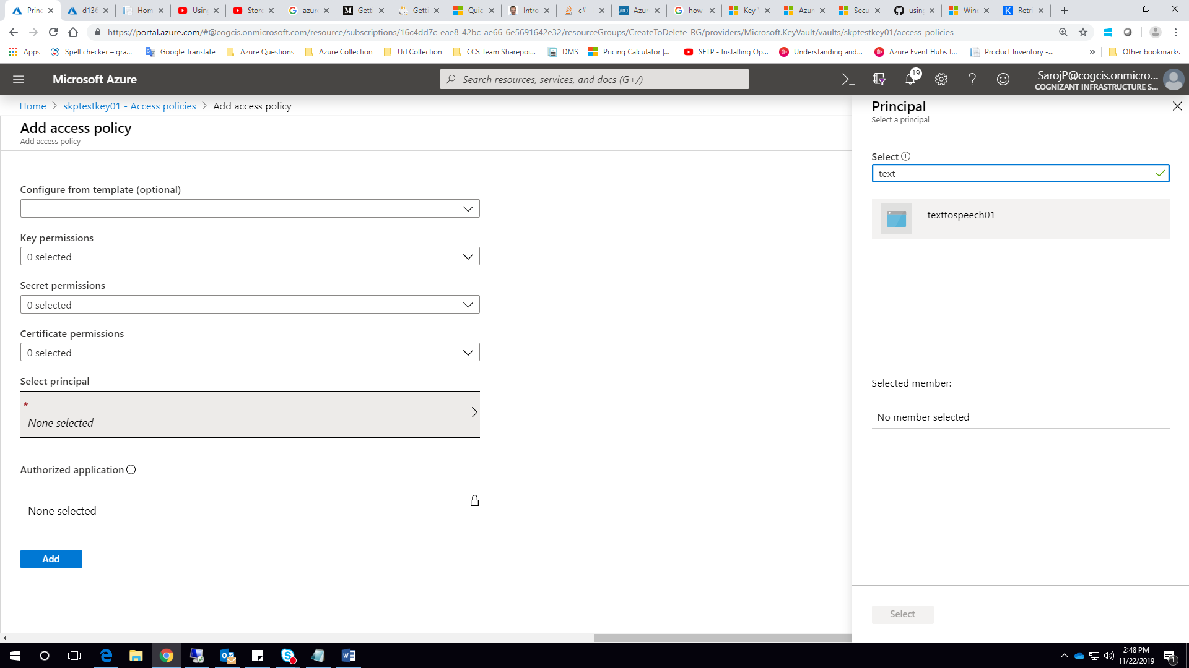

Select principle and select your app service and add and set Secret permission only Get.

1. Add the application in IAM if needed

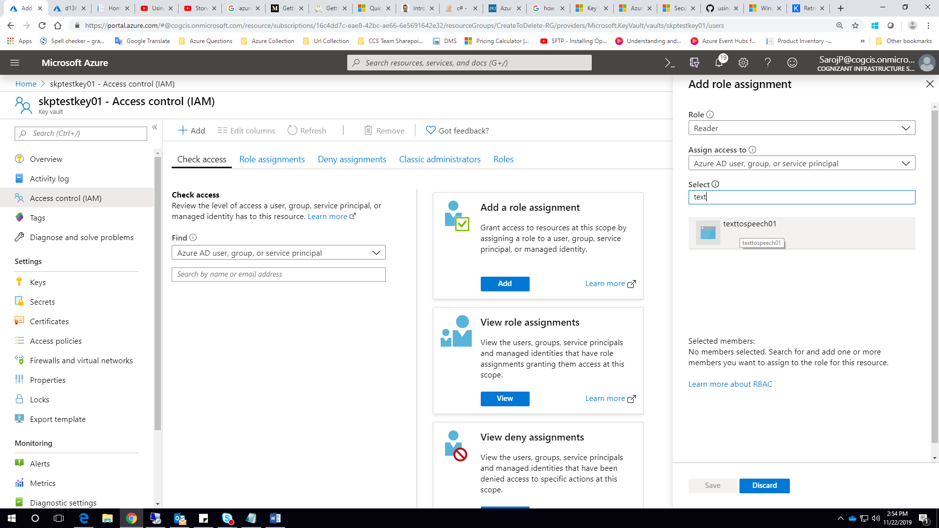

1. Go to secret key option and get the secret identifier

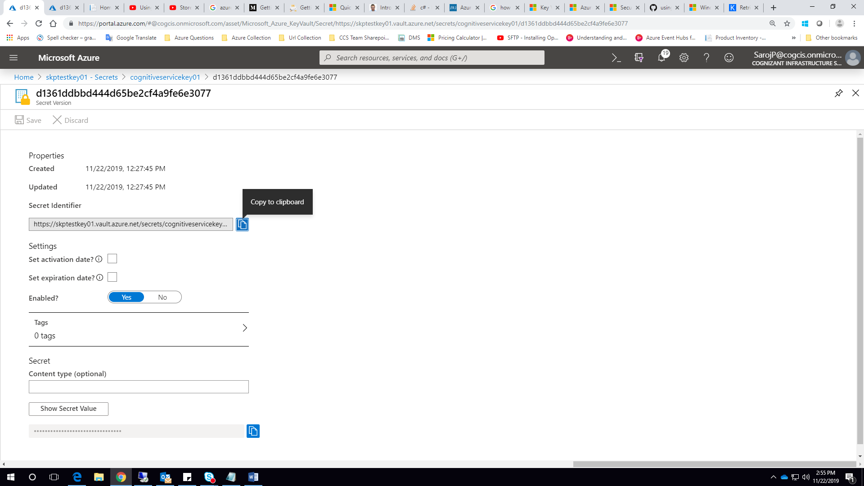

1. Go to application settings in your App service in azure and add a new key with value in below format (<https://docs.microsoft.com/en-us/azure/app-service/app-service-key-vault-references>)

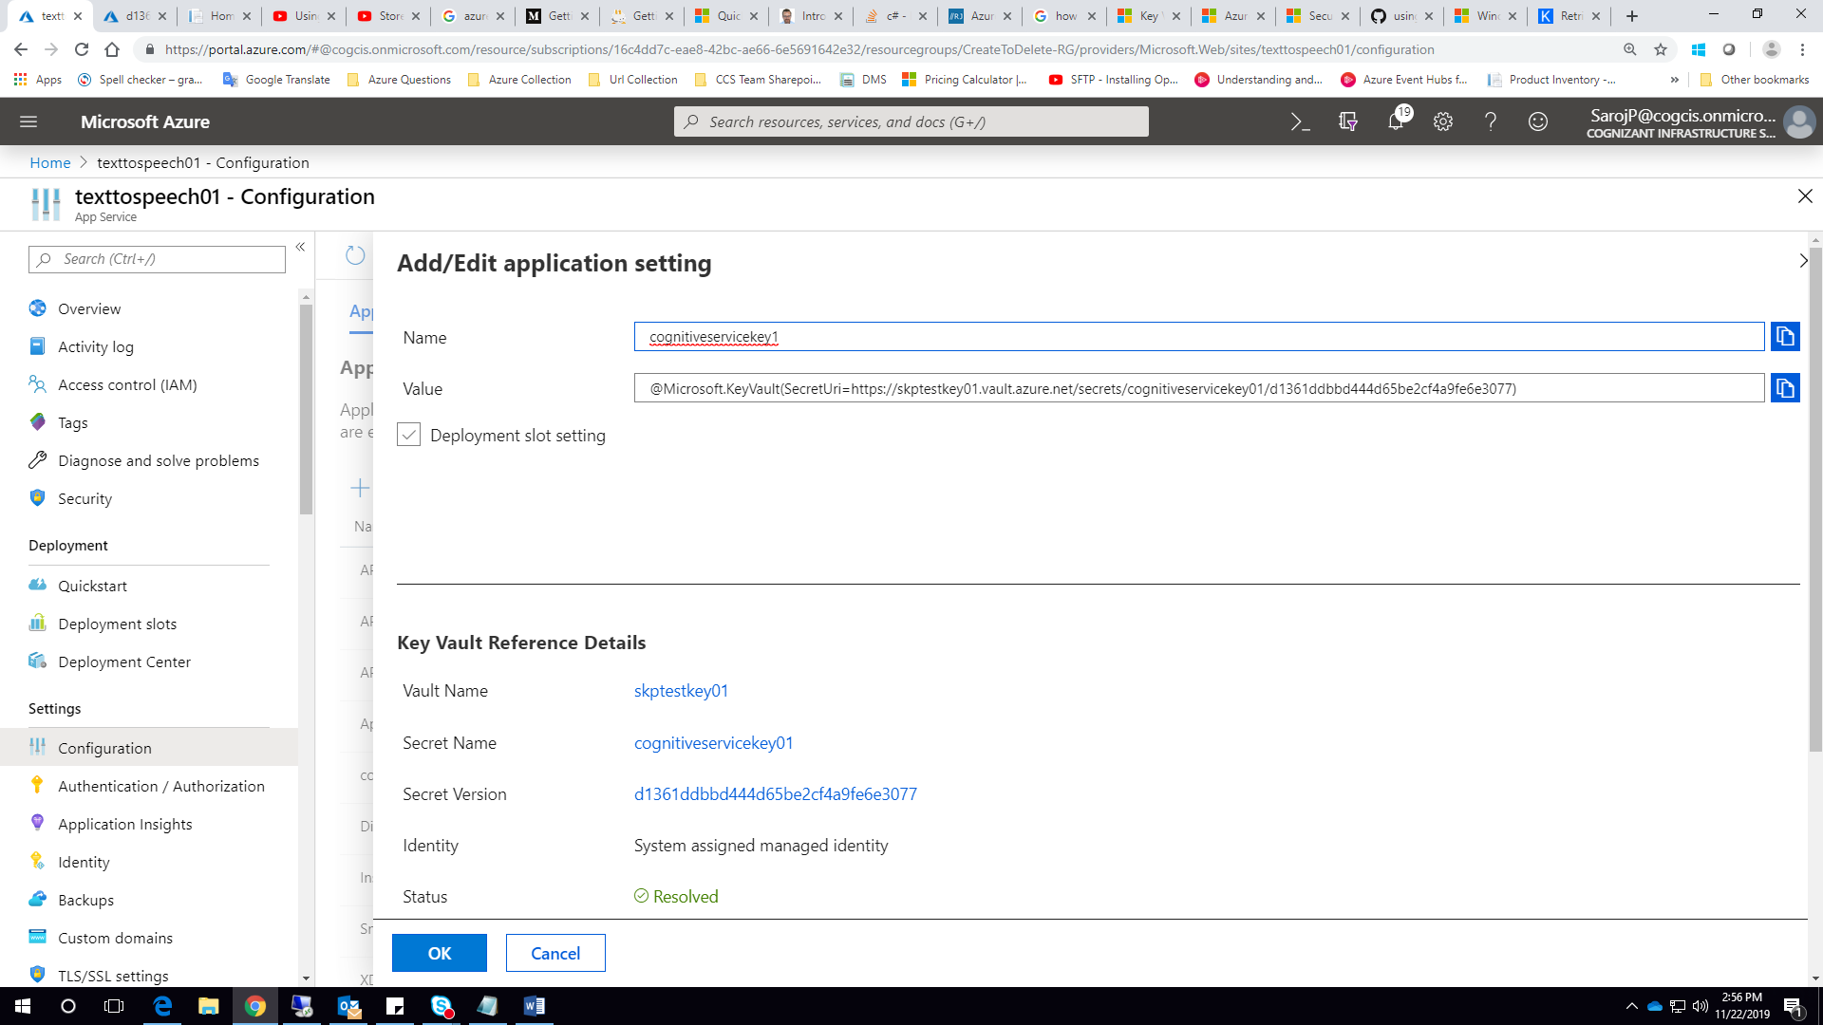

@Microsoft.KeyVault(SecretUri=https://myvault.vault.azure.net/secrets/mysecret/ec96f02080254f109c51a1f14cdb1931)

Alternatively:

@Microsoft.KeyVault(VaultName=myvault;SecretName=mysecret;SecretVersion=ec96f02080254f109c51a1f14cdb1931)

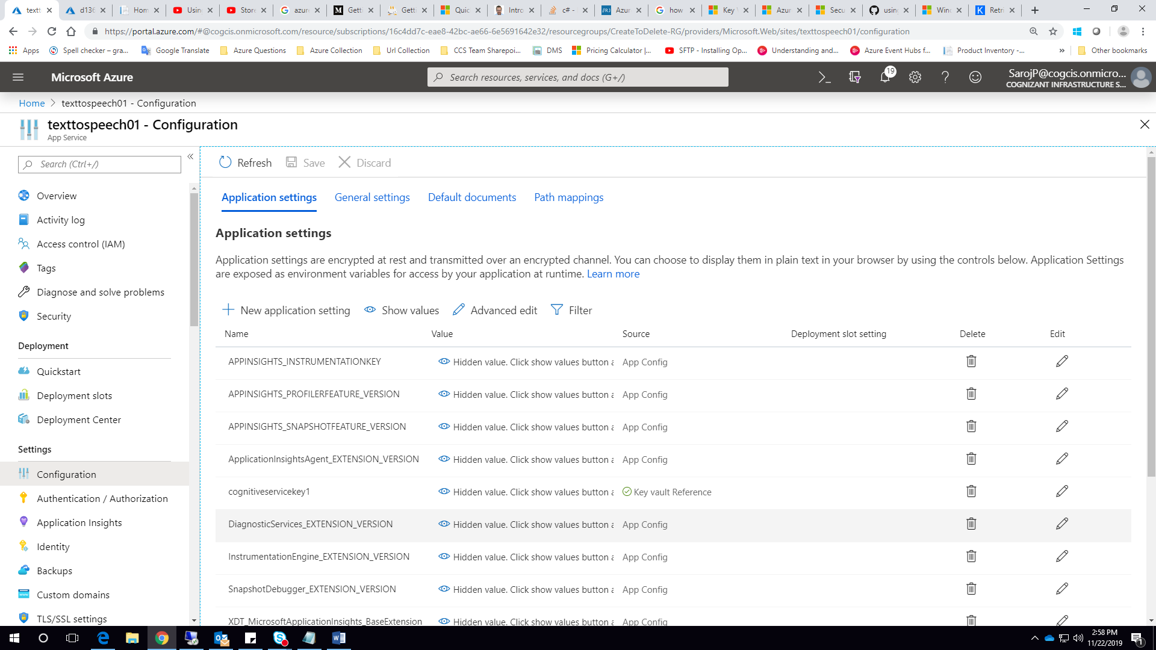

1. Then go to your C# code and write the code

